

FirstMate™ 4.0

- Owner’s Manual -

February 2007

TechMate International
23121Verdugo Dr. Suite #103 Laguna Hills, CA 92653
(800) 837-6283

Preface
TechMate International is dedicated to the Moving Industry and is committed to be your technology partner. FirstMate is one of the software products from the TechMate family.

Disclaimer
TechMate International makes no representations or warranties with respect to the contents or use of this manual, and specifically disclaims any express or implied warranties of merchantability or fitness for any particular purpose. Further, TechMate International reserves the right to revise this publication and to make changes to its content, at any time, without obligation to notify any person or entity of such revisions or changes.

Copyright © 1990-2007 TechMate International. All rights reserved. No part of this publication may be reproduced, photocopied, stored on a retrieval system, or transmitted without the express prior written consent of TechMate International.

Table of Contents

1.0 INTRODUCTION 4
1.1 About This Document 4
2.0 Installing FirstMate 2
2.1 Starting FirstMate for the first time 2
3.0 FirstMate, Setup 3
3.1 Managing Carrier Lists 3
3.2 Managing the Agents List 3
3.3 User (Sales person) Lists 4
3.3.1 Maintaining the User list 4
3.3.1 FirstMate Access and Rights 4
3.3.1 Branch and Access 5
Access Rights 5
4.0 Setting up Rating Files 6
4.1 Managing the Valuation File Lists 6
4.1.1 Setting up a Valuation File 6
4.2 Managing the Container File List 7
4.2.1 Setting up a Container File 7
4.3 Managing the Tariff Files List 7
4.3.1 Initializing Tariffs 8
4.3.2 Valuation Rates 8
4.3.3 Container Rates 8
5.0 Setting up Connections with a Portable TechMate International Product 9
5.1 Setting up a Connection with SalesMate/Telxon 9
5.1.1 Connecting SalesMate/Telxon to FirstMate 9
5.1.2 Changing the Comm. Port in FirstMate 9
5.1.3 Common Programs that use the Comm. Port 9
5.2 Setting up a Connection with Pocket SalesMate 10
5.2.1 Trouble Shooting Pocket SalesMate Problems 10
6.0 Customizing FirstMate 11
6.1 FirstMate Defaults Tab 11
6.2 FirstMate Display/Reports Tab 11
6.3 FirstMate License Tab / Entering a FirstMate Key 12
6.4 FirstMate Node Tab 12
6.5 Customer Display Tab 12
6.6 Interfaces Tab 13
6.7 Co-Resident Applications 14
7.0 Collecting Customers Information in FirstMate 15
7.1 Primary Data Screen 15
7.1.1 Adding Notes 15
7.1.2 Displaying or Printing the Primary Data Report 16
7.2 Survey Screen 16
7.2.1 The Inventory List 16
7.2.3 Adding Articles to the Survey 17
7.2.4 Changing the Quantity and Size of an article 17
7.2.5 Adding Comments/Contents to an Article or Carton 17
7.2.6 Adding Miscellaneous Rooms and Articles 18
7.2.7 Entering Crates 18
7.2.8 Displaying or Printing the Primary Data Report 19
7.2.9 Printing Bar-Coded Labels 19
7.3 Rating 20
7.3.1 Tariff Selection 20
7.3.2 Tariff’s Bind Date 20
7.3.3 Rating Data Tab 20
7.3.4 Transportation Charges 21
7.3.5 Local Transportation & Labor Charges 21
7.3.6 Valuation Charges 21
7.3.7 Cartons, Packing & Unpacking Charges 22
7.3.8 Extra Stops / Mini Storage Charges 22
7.3.9 Appliance Servicing Charges 22
7.3.10 Elevator, Stairs & Long Carries Charges 23
7.3.11 Piano/Organ Charges 23
7.3.12 Storage (S.I.T) Charges 23
7.3.13 Other Storage Charges 23
7.3.14 Miscellaneous Charges 23
7.3.15 Extra Labor / Shuttle Charges 23
7.3.16 Bulky Article Charges 23
7.3.17 Taxes Charge 23
7.3.18 Discounting 23
7.3.19 Estimate Type 24
7.3.20 Total Charges (changing) 24
9.0 Interfaces with TechMate’s Portable Products 24
9.1 SalesMate/Telxon 24
9.2 Pocket SalesMate 24
9.2.1 Sending a Customer to Pocket SalesMate 24
9.2.2 Sending a Customer from Pocket SalesMate 25
Creating and Editing Articles 26
Groups 26
Creating Rooms and Assigning Groups 28
Sending the Customized Master Inventory to Pocket SalesMate 29
Scheduler 29
Scheduler 30
Displaying Appointments 31
Creating an appointment 31
Additional Residence Information Screen 32
Additional Residence Information Screen 33
Reminders 34
Customize Generic Verbiage for Local and Intrastate Tariffs 36
Setting Tariff Defaults 38
Remote Tablet FirstMate Connecting to the Office Data 38
Remote Tablet FirstMate Connecting to the Office Data 39
Popup Calendars 39
Left-Handed Survey Screen 39
Left-Handed Survey Screen 40
Complete Additional Extra Pickup and Delivery Addresses 41
Origin Address Map 42

1.0 INTRODUCTION

FirstMate has many uses both inside and outside of the office. Inside the office, FirstMate can be used in conjunction with TechMate International’s line of portable products to provide a point of origin for customer information, which cuts out the need for duplicate data entry. The customer information is entered into FirstMate and then moved to SalesMate/Telxon or Pocket SalesMate so the estimator does not spend precious sales time while in the home. After the survey information has been captured and an estimate/order for service prepared, the survey and rating information can be sent to FirstMate for permanent retention while also freeing up room on the portable device
FirstMate is a fully functional rating tool so all the survey and rating information is available. This is extremely useful in the event a customer wants to make changes to the survey and the salesman with the portable SalesMate estimating tool is not in the office, an assistant can make the changes in FirstMate, re-rate the survey and email a new Estimate Order for Service directly out of FirstMate. FirstMate can also be used as a marketing tool for managers with a line of “month end” type reports like the Booked, Salesmen, Status and Financial reports.
Since the licensed version of FirstMate is a fully functional rating tool, it can be installed onto a table PC and used exclusively as a portable rating tool.

1.1 About This Document
This manual assumes the user has a working knowledge of any additional software (I.E. Pocket SalesMate, SalesMate/Telxon) being used in conjunction with FirstMate. If you are a first time user, you should read and following the directions in the shaded boxes.
These are designed as training aids and if performed, should be sufficient to get you ready to start using FirstMate in your business.
The term click is used throughout this document to indicate a left click.
Here are some common buttons you will see in FirstMate:

Exit: This will Exit the current window. If changes have been made, you will be prompted to save?

Add New: Use the icon to enter a new item (e.g. Customer).

Save: When highlighted, use to save any changes or new information.

Delete: This will delete any information or hi-lighted records.
Display: This will display reports and printouts to screen for review before sending to printer.

Print: This will print a report to the default Windows printer.

Notes: This is used to enter notes for a customer in the Primary, Survey and Rating Data screens.

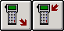Upload and Download: These are used to transfer customer(s) to/from SalesMate/Telxon.

2.0 Installing FirstMate
If you are Installing FirstMate from a CD: insert the CD. The CD has an auto run feature so the installation should start up automatically. If installation does not start automatically, click Start – Run – Browse - select the CD drive and double click on the Setup application icon.
If you’re Installing FirstMate from the Web: Go to the www.TechMateiIntl.com web site. Under Updates, select FirstMate. There is a link for the most current CD Image for FirstMate. The CD Image is a self-extracting zip file that contains the image of the CD. Enter the user name and password. If you are installing a single user version of FirstMate, select the option to Open or Run if you can. If you are installing a multi-version of FirstMate, you may want the select Save, as FirstMate will need to be installed on each computer that will have FirstMate. Note that Netscape and some of the other web browsers do not give the Open or Run options. If you select the Save option, note the name of the file and where the file is being saved and go ahead and save. You will then need to manually go to the directory that the file was saved and double click to run it. When you run the file, the WinZip self-extractor will come up. Note the location of where the files are going to be uncompressed and click Unzip. After the files have been uncompressed, click OK and then Close. Go to the location the files were extracted and run the Setup application file.
The InstallShield Wizard will start and you’ll be prompted to enter the location where FirstMate is to be installed, etc. It is recommended to install using the defaults. Continue through the wizard and click install to complete the installation.

2.1 Starting FirstMate for the first time
New FirstMate installations have a fully functional 60-day trial period to allow you to see what FirstMate can do and how it can help your business. After the trial period has expired, FirstMate will revert to a Maintenance Edition. The Maintenance Edition allows you to maintain Tariffs, Agents, etc. for SalesMate/Telxon and Pocket SalesMate.

3.0 FirstMate, Setup
New FirstMate installations have a fully functional 60-day trial period to allow you to see what FirstMate can do and how it can help your business. After the trial period has expired, FirstMate will revert to a Maintenance Edition. The Maintenance Edition of FirstMate will allow you to maintain Tariffs, Agents, etc. for SalesMate/Telxon and Pocket SalesMate.
If you click on Setup you will get a drop down list of FirstMate’s Setup options. These are divided in areas as shown in the diagram. The first area is Agents, Carriers and Lead Sources.
The second area has to do with setup of Tariffs, Container and Valuation files.
The next is Users. If the user is a salesperson, this is where you will indicate what device he is using and his sales id. This can also be used to establish a sign on for access to FirstMate.
FirstMate can be used to produce bar-coded tag stock for use by drivers and packing crews. You can design you own labels and then they can be printed on any Windows supported printer.
The last area is for Setup of FirstMate and Setup of SalesMate/Telxon.
Start FirstMate by double click the FirstMate icon on your desktop.

3.1 Managing Carrier Lists
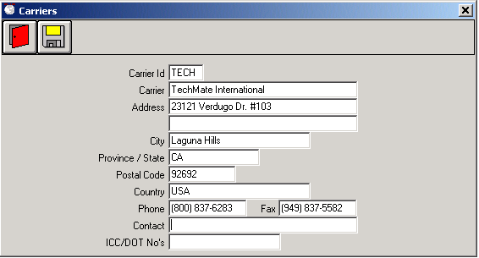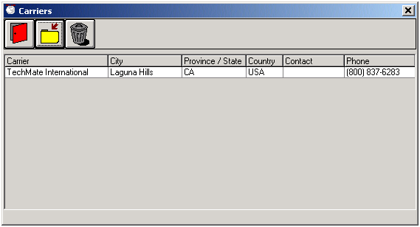A list of Carriers can be created and maintained in FirstMate from the Carriers screen. The Carriers screen can be found by clicking on the “Carriers” option in the Setup Menu on the Main screen. The Carriers screen will display a complete list of all the Carriers that have been added to FirstMate. To add a new Carrier, click on the Add New button. To view or modify a Carrier, simply click on the agent. To delete, highlight the agent by right clicking on the agent and then click on the Delete button.
For agents not under their own authority, it is recommended that if your carrier is not already in the carrier list, you obtain a Carrier file for your carrier from www.TechMateIntl.com that will include the carrier address and valuation file for the 400N.
If your FirstMate does not have a Carrier and your agency is under it’s own authority, you can enter your Carrier information now. If your FirstMate does not have a Carrier and your agency is not under it’s own authority, contact TechMate International to obtain the carrier file for your carrier.

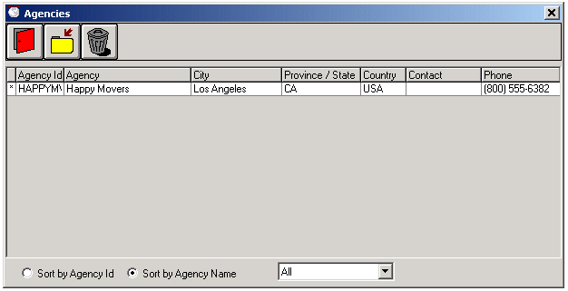3.2 Managing the Agents List
A list of Agents can be created and maintained in FirstMate from the Agencies screen. The Agencies screen can be found by clicking on the “Agent” option in the Setup Menu on the Main screen. The Agencies screen will display a complete list of all the agents that have been entered into FirstMate. To add a new agent, click on the Add New button. To view or modify an agent, simply click on the agent. To delete, highlight the agent by right clicking on the agent and then click on the Delete button.
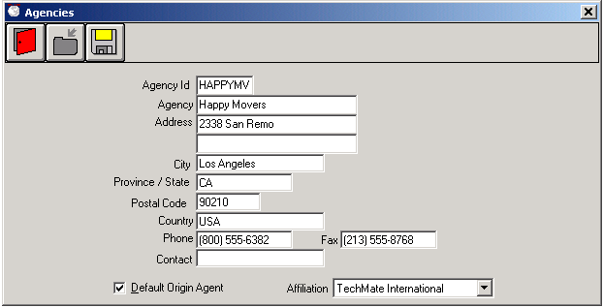Click on Setup and then Agents. Click on the “add new Agent” button. Enter your agency name and address and check the Default Origin Agent box and select your carrier from the Affiliation drop down list. After all the information is entered, click on the Save button and then the Exit button. You should now see your Agency in the list.

User (Sales person) Lists
There are several reasons for setting up users in FirstMate. In an office where multiple sales people will use FirstMate, FirstMate can be setup to restrict user’s access to only their own customers and month end reports can sort the customers by sales people. Using one of TechMate Internationals portable products will also require you to setup the user in FirstMate prior to connecting the device.

3.3.1 Maintaining the User list
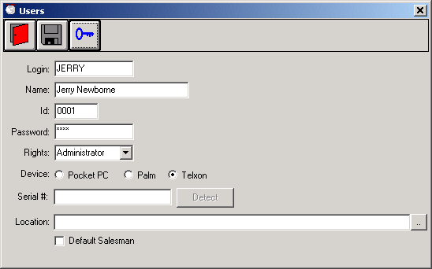
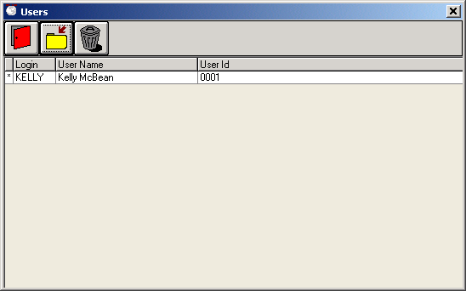
To add a new user, click on the Add New button and enter a unique Login. The name will be displayed on month end reports and should also be entered. The Id field is used in conjunction with the Salesman ID in SalesMate/Telxon (This will be further discussed in 5.1.1 Connecting SalesMate/Telxon to FirstMate). If the salesperson is using SalesMate/Telxon, make sure the Id is the same as the Salesman in the setup of SalesMate/Telxon. Note: The Id is a required field so users of Pocket SalesMate will also need to enter a unique Id. If you plan on setting up FirstMate to force Login, click on the Key button to add a password (for more information, see 3.3.1 FirstMate Access and Rights). Select the Device. Note for Pocket PC users: Setting up the connection will be discussed in section 5.2 Setting up a connection with Pocket SalesMate. After all the data has been entered, click on the save button and then Exit. To view or modify a user, simply click on the user. To delete, highlight the user by right clicking on the user and then click on the Delete button.
Click on Setup and then Users. Click on the “add new User” button. Enter a Unique Login, the Users name and ID. If you plan on setting up FirstMate to force Login, click on the Key button to add a password. Select the Device. Click on the Save and then the Exit button. You should now see your new user.

FirstMate Access and Rights
FirstMate can be setup to enforce individual logins with passwords to gain entry into FirstMate and limit user’s access. There are various levels of access. Administrator has full access. Salesman access is limited. See “Rights” on the next page for more details.

3.3.1 Branch and Access

Agencies with multiple branches all connecting into a single FirstMate data set can now segregate the customers, users, tariffs, container and valuation files so they can only be viewed by the associated branches.

To get started, each office must be designated as a Branch Office. After each office has been set as a branch, these offices will be displayed in Branch dropdown menus in the Users, Tariffs, etc. screens.

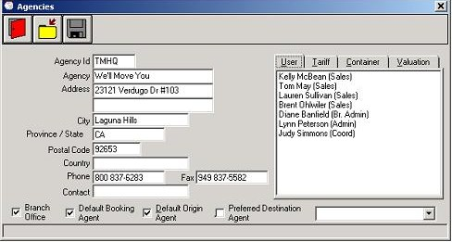

Access Rights

- Salespeople will only have the ability to add and modify customers assigned to them, but not delete. Salespeople will only be able to select tariffs that are assigned to the branch they are in. Salespeople will only be able to run reports for customers assigned to them.

- Coordinators have the ability to add and modify customers assigned to any sales person in the same branch as the coordinator is assigned, but not delete customer.

- Branch Coordinators have the ability to work with any customer assigned to a sales person in the same branch, including deleting customers. Additionally, the branch coordinator has the ability to modify tariff, container and valuation files as well as assigning files and users to their own branch. Branch coordinators can also run reports for the entire branch.

- Administrators: Full access to all information across all branches.

4.0 Setting up Rating Files
FirstMate is a fully functional rating tool.

4.1 Managing the Valuation File Lists
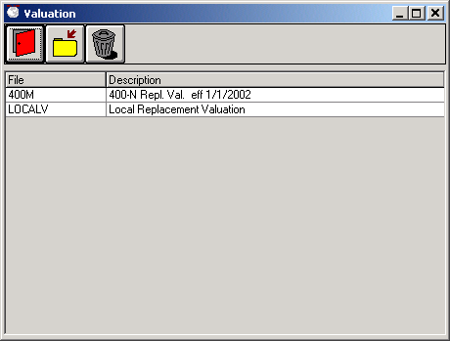
A list of Valuation files can be created and maintained in FirstMate from the Valuation screen. The Valuation screen can be found by clicking on the “Valuation Files” option in the Setup Menu on the Main screen. The Valuation screen will display a complete list of all the Valuation files that have been entered into FirstMate. To add a new valuation file, click on the Add New button. To view or modify a valuation file, simply click on the valuation file. To delete, highlight the file by right clicking on the valuation file you wish to delete and then click on the Delete button.

4.1.1 Setting up a Valuation File
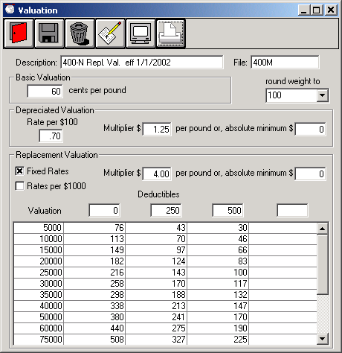
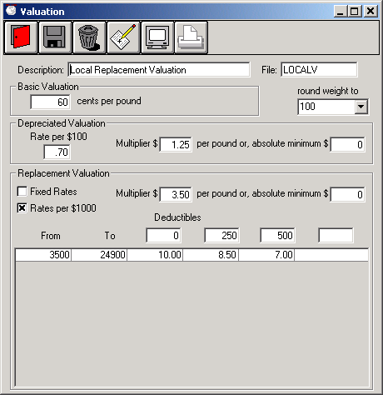
Setting up valuation files in FirstMate is divided into 3 sections. The first section is the Description and File name. Enter any description that best describes what the valuation file is for. For the file name, you can only use alphabetic (a-z) and numeric (0-9) characters, no “.”, “/”, “\”, etc.
Valuation files for inter-state Tariffs most major Carriers can obtain a pre-built carrier file from www.TechMateIntl.com. When downloading the Carrier, the most current Valuation Rates will be included. Agents operating under their own inter-state authority MUST use the Carrier Id that was entered for their Carrier for the File Name in the Valuation File (it is recommended that you user your SCAC code for this ID).
The second and third sections are for entering the Basic and Depreciated Valuations. Rates must be entered into the fields, so if you do not use Basic or Depreciated valuation, make the rates 0.
The final section of the valuation screen pertains to the Replacement valuation. There are two types of replacement valuation, Fixed Rates and Rates per $1000. Make sure you enter the appropriate type before entering rates because any replacement rate entered will be cleared out when changing type. You will be able to enter up to four deductibles and any deductible not used can be left blank. To enter rates, click on the “Paper and Pencil” button to add a line for rates. For Fixed Rates, on the new line, enter the Valuation and rates for each deductible. These rates are whole dollar and do not include cents so do not add a decimal. For Rates per $1000, the “From” amount will automatically be filled in from the Multiplier/Absolute Minimum. Enter the maximum valuation you will sell under the “To” amount. The rates for Rates per $1000 can include the decimal or cents. If you leave the decimal off, FirstMate will automatically add it (i.e. if you enter 10, FirstMate will display it as 10.00.)
Let’s add a valuation file using Rates per $1000 for a Local Tariff. We will use the sample Local Valuation Rates screen on the right but if you know or have your local valuation rates, go ahead and enter them now with the exercise. From The main FirstMate screen, click Setup and the Valuation File. Click Add New to create a new valuation file. Enter a description that makes sense, in the sample, we use “Local Replacement Valuation.” Enter a File name (again the example uses LocalV). The sample uses the default Basic and Depreciated valuation rates but if yours are different or you just want to try changing them, do so now.
Our sample uses Rates per $1000, so if it’s not checked, change it so it is. Change the default Multiplier and Absolute Minimum if you want. Enter deductibles of 0, 250 and 500 if you are following the sample, or your own rates if your creating your own Local Valuation file. Go ahead and click on the “Paper and Pencil” button to add a new line for our rates. Click on the new line under the “To” column and enter 250000, or your own amount for the maximum valuation you want to sell. Press the Tab key to move to the next column and enter the rate. For our sample, enter 10 then press the Tab key (you should notice the amount changes to 10.00) and enter 8.50 then Tab key again and enter 7. Now click on the Save button to save the file then the exit button to get back to the Valuation screen and you should now see the valuation file you just created.

4.2 Managing the Container File List
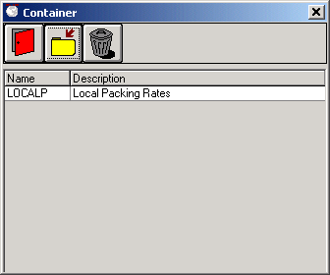
A list of Container files can be created and maintained in FirstMate from the Container screen. The Container screen can be found by clicking on the “Container Files” option in the Setup Menu on the Main screen. The Containers screen will display a list of all Container files that have been entered.
To add a new container file, click on the Add New button.
To view or modify an existing container file, simply click on the container file.
To delete a Container File, highlight the container file by right clicking on the file you wish to delete and then click on the Delete button.

4.2.1 Setting up a Container File
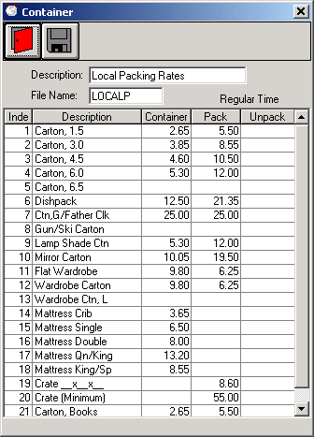
If you are Rating with the Local, Intra-State, International, TPG or APP Tariffs in FirstMate or SalesMate/Telxon, you will need to enter a Container File. Note that a Container File can be used by more than one tariff.
Each Container File needs a Description and a File Name. The description should describe what the container file is for (e.g. Local Packing Rates). The File Name is used within the Tariff to identify the Tariff. The file name is limited to 8 characters (limited to alphabetic (a-z) and numeric (0-9) characters, no “.”, “/”, “\”, etc).
The Containers are those currently available in TechMate International’s line of products. When entering Rates, you can use the Tab key to forward through the rates.
The Container Rate file has entries for the Container (material) rate, the Packing Rate (labor) and the Unpacking Rate (labor). All TechMate Tariffs allow you to show Container and Packing Rates separately or combined into a Single Packing Rate. This is done in the Setup of each individual Tariff. If a Single Packing rate is used, the Container and Packing Rates will be added together. Allied’s TPG Tariff uses unpacking rates from the published Tariff, so the unpacking rate (if entered) would not be used. The 400N tariff uses rates published with the tariff and does not use a Container File.
Let’s add a container file for a Local Tariff. We will use the sample Local Container screen on the left but if you know or have your local container rates, go ahead and use your rates instead. From The main FirstMate screen, click Setup and the Container File. Click Add New to create a new Container file. Enter a description that makes sense, in the sample, we use “Local Packing Rates.” Enter the File name; again the sample uses “LocalP.”
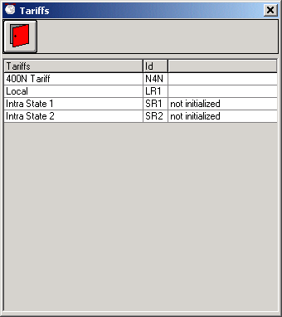
To enter the rates, click under the word container for the Carton 1.5. The sample rates for the Carton 1.5 is 2.65, 5.50 and the Unpack Rating is being left blank. So enter 2.65 and press the Tab key then enter 5.50 and press the Tab key again. Since there are no Unpack rates, just press the Tab key again to move back to the Container rate for the next carton. If you are just doing the sample, enter a few more carton rates until you feel comfortable with the entry process. If you are entering your Local Container rates, continue through and enter all rates. Once you have completed enter rates, click the Save button and then the Exit button. You should now see the Container file you just created in the list.

4.3 Managing the Tariff Files List
The list Tariff files is maintained in FirstMate from the Tariffs screen. The Tariffs screen can be found by clicking on the “Tariff Files” option in the Setup Menu on the Main screen. The Tariffs screen will display a complete list of all the tariff files that can be used in FirstMate and their current status, Not Initialized or Initialized (blank entry in the Tariff screen). Tariff must be initialized prior to using them in FirstMate. To view or initialize a tariff file, simply click on the valuation file. Tariff files cannot be added or deleted from FirstMate. If you are missing a tariff file, contact TechMate International to obtain a file that will add the tariff to your list.

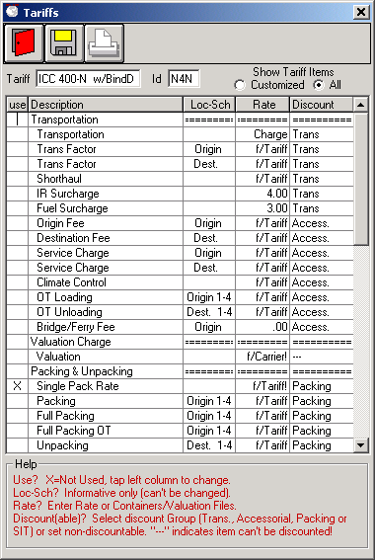
4.3.1 Initializing Tariffs
Tariffs must be initialized before they can be used. Tariff items are arranged in Groups for display and report purposes (e.g. Transportation, Packing & Unpacking, Storage etc.). The heading for Groups are shown with trailing “=” as shown in the example. Both Groups and Items can be turned on or off by clicking the left column. An”X” in the left “use” column indicates that a group or item has been turned off. If the “Show Tariff Items” selection is set to “Customized”, Groups and Items that have been turned off will not be displayed. To display all Groups and Items, select “All” below “Show Tariff Items”. Note that if a Group is turned off, all Items in that Group will be effectively turned off (it is not necessary to turn the Items off).
Containers are a special case. The 400N Tariff introduced the concept of combining the Container Cost and Packing Charge into a single charge (Single Pack Rate). FirstMate allows you to change this to separate the rates and also allows all Tariffs to have the choice of a Single Pack Rate or have Container and Packing Rates separated. The default for the 400N Tariff is a Single Pack Rate. The default for all other Tariffs is to use separated rates.
If the rate for an Item is not published with the Tariff, click on the “Rate” column and enter the desired rate.
The discount column indicates if an item can be discounted and if discounted, what group it is discounted with. If you want to change how the item is discounted, click on discount column. An “---“ indicates that the Item can’t be discounted.
Once the Tariff has been setup, you can print a copy of the Customized Tariff by clicking on the printer icon. If you have salespersons using Pocket SalesMate, the Tariff can be setup in FirstMate and then downloaded to Pocket SalesMate.

4.3.2 Valuation Rates
Since most Carriers file their own Replacement Valuation Rates, supported Inter-State Tariffs (400N, TPG, 400M. B412, etc.) are able to use Valuation Rates filed by the Carrier. If a Carrier is not designated for a Customer, or if there is not a matching Carrier Valuation File, the default 400N Replacement Rates will be used.
All other tariffs need to have an associated Valuation File set in the Tariff. To assign a Valuation File, click on the Rate column for Valuation (not the group entry) and select the appropriate File form the list.

Container Rates
Most Inter-state Tariffs (400N, 400M. B412, etc.) have Container, Packing and Unpacking Rates in the Tariffs.
Inter-state Tariffs (TPG) use Unpacking Rates filed by the Carrier. The Container and Packing Rates need to be entered in a Container Rate File and then selected within Tariff Setup. To assign a file for Container and Packing Rates, click on the Rate column for any one of the Container or Packing Items and select the appropriate File form the list.
All other tariffs need to have an associated Container File set in the Tariff. To assign a Container File, click on the Rate column for any one of the Container, Packing or Unpacking Items (not the group entry) and select the appropriate File form the list.

5.0 Setting up Connections with a Portable TechMate International Product
FirstMate can be used in conjunction with both SalesMate/Telxon as well as Pocket SalesMate. For SalesMate/Telxon users, continue setup with section 4.1. For SalesMate/Telxon, continue with section 4.1 Setting up a Connection with SalesMate/Telxon. For Pocket SalesMate users, skip to section 4.2. Setting up a Connection with Pocket SalesMate.

5.1 Setting up a Connection with SalesMate/Telxon
SalesMate/Telxon uses a standard RS232 comm. port on your PC with a “PC to Telxon” cable (if you don’t have a PC to Telxon cable, contact TechMate International to obtain one.) to send data back and forth between FirstMate. If the PC does not have a standard comm. port, you will need to have one installed in order to connect FirstMate and SalesMate/Telxon (ask your network administrator or hardware dealer for options). If your PC only has USB ports, USB to RS232 converters are available (again, consult your network administrator).
To set up the link with a SalesMate/Telxon, Start FirstMate. At the bottom of main FirstMate screen, there is a status message. If the status message says, “Comm. n is Open”, you should be ready to connect your SalesMate/Telxon to FirstMate. (See Connecting SalesMate/Telxon to FirstMate) If the status message reads “Comm. Port n is Invalid”, the comm. port FirstMate is on is either invalid or not configured properly so you will need to use a different comm. port (see. Changing the Comm. Port in FirstMate). If the status message reads “Comm. n is in use by another task!” the Comm. Port is currently busy. Check “Common programs that use a Comm. Port”.

5.1.1 Connecting SalesMate/Telxon to FirstMate
Plug the PC to Telxon cable into the comm. port in the PC and the other end into the Telxon. Turn on the SalesMate/Telxon. From the SalesMate menu on the Telxon, press the [B] button. If the SalesMate/Telxon screen displays “FirstMate Online”, congratulations, you’ve established a connection between FirstMate and SalesMate/Telxon. If SalesMate/Telxon beeped at you and the screen remained at SalesMate Menu, the connection was not established. Verify the PC does not have another comm. port that you can plug the PC to Telxon cable into. If it does, change the plug and try again. If you still are unable to get a connection, you can try changing the comm. port in FirstMate (see Changing the Comm. Port in FirstMate) and repeat the connection process. Remember to try all comm. port plugs in the PC if for each comm. port setting in FirstMate.

5.1.2 Changing the Comm. Port in FirstMate
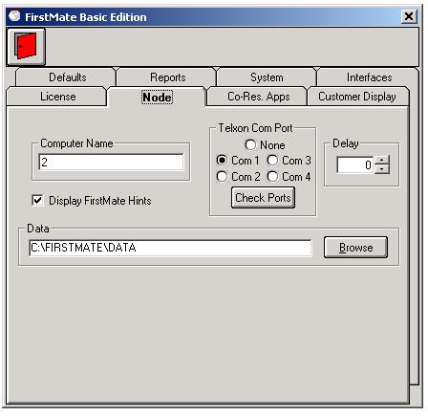You can use FirstMate to determine what comm. ports are available on your PC. From the Main FirstMate screen, click Setup, FirstMate and then the Node tab. To see which comm. ports are available, click on the Check Ports button. All the non-active comm. ports will be disabled so change the port to an available port in FirstMate. After changing comm. ports, you will need to exit completely out of FirstMate and then restart FirstMate for the changes to take effect. Note: A comm. port that is currently setup for use by HotSync or ActiveSync will be displayed as disabled when checking for valid comm. ports so if FirstMate is going to share the comm. port with either type of device, you will need to shut off ActiveSync or HotSync before starting FirstMate (see Common Programs that use the Comm. Port).

5.1.3 Common Programs that use the Comm. Port
Pocket PC and Palm Pilot devices use software that gets loaded into memory when you turn on your PC. To shut down ActiveSync or HotSync, bring up the Task List, (press CTRL+ALT+DEL) select the Active or HotSync and click on End Task. You will then need to shut down and restart FirstMate.

5.2 Setting up a Connection with Pocket SalesMate
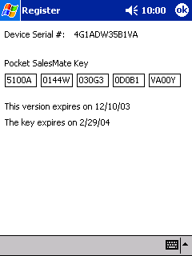
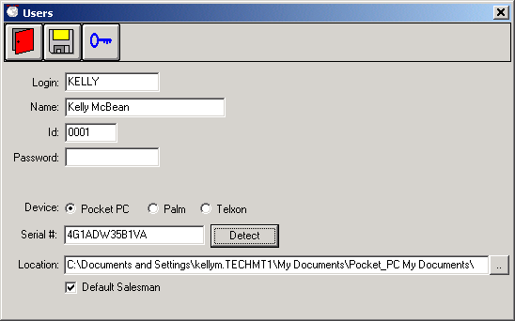
Start Pocket SalesMate and Sync the Pocket PC device. A partnership must be established; it cannot be setup as a guest. When the partnership is created, in the synchronization Settings screen, make sure the "Files" is checked so that the customer "files" will get synchronized. In Pocket SalesMate, go to the Register screen. (Setup | Register) The Device Serial # will be displayed at the top of the screen. Go back into the Users Screen and select the user that will correspond to this Pocket SalesMate. If the user is not there, create one (see Managing User Lists). Make sure the Pocket PC button in selected and enter the Device Serial Number into the Serial # box. Establish the link by clicking on the Detect button. When the “FM_Sync.PSM” file is found, the location of the Sync folder will be entered into the Location box. Click the yellow disk to save the user information.
It is recommended to include the Salesperson ID (I.D.) and Customer Sync Status (Sync) fields to the customer display. Setting up the display screen will be covered later in this manual.

5.2.1 Trouble Shooting Pocket SalesMate Problems
If FirstMate does not find the FM_Sync.PSM file, verify the Device Serial # entered is correct. Verify the version of Pocket SalesMate supports the XML interface. Using Windows Find Files, search for the FM_Sync.PSM in the PC. If it does not exist, either the version of Pocket SalesMate does not support the XML interface or there was a problem with Syncing through Microsoft Active Sync. The FM_Sync.PSM file in the PC could also be corrupt. Using Windows Find Files, find and delete the FM_Sync.PSM in the PC. Repeat the “Sync the FM_Sync.PSM” step.

6.0 Customizing FirstMate
With FirstMate, you have the ability to customize regional setting like language and units of measure as well as how you survey in FirstMate. To setup FirstMate Defaults, click on FirstMate from Setup on FirstMate’s main menu.

6.1 FirstMate Defaults Tab
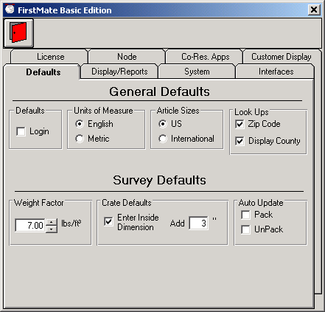
Login: FirstMate can be setup to force individual users to login to FirstMate. The advantage is when the user logs in; FirstMate will only display his or her customers.
Units of Measure: Units of Measure can be set to either English (cubic feet) or Metric (cubic meters).
Article Sizes: FirstMate contains two sets of default sizes (US and International) for the article list. US sizes are biased toward the expected weight of an Article while International sizes are base on the actual default size.
Look Ups: FirstMate can automatically lookup and enter the City, State and County (within the United States) by simply entering a postal code in FirstMate. If you are using a Tariff that is State and County based (i.e. TPG, 400M, B412), you should also chouse Display County.
Auto Update: While surveying in FirstMate, FirstMate can be set to automatically increment the Pack and/or Unpack quantities any time you increase the quantity of cartons.
Weight Factor: This is the weight factor that will be initially set for a Customer when the Customer is created.
Create Defaults: You can enter the inside dimensions of an Article being crated and have FirstMate adjust the crate’s size automatically. If you do not select this option, you will need to enter the outside dimensions of the crate (not the dimensions of the Article).

6.2 FirstMate Display/Reports Tab
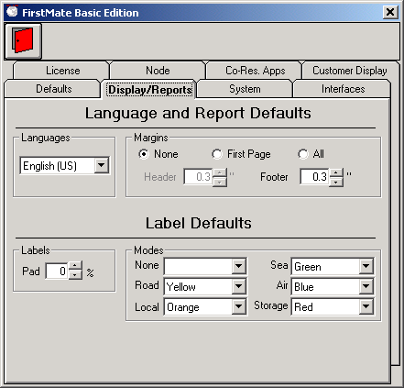
Languages: You can set the language FirstMate will display in. (Currently on survey modes, rooms and articles are set to display in multiple languages but full language support will be added in the future.) The current display language will also determine the default report language as well, however for the customer reports, you will have the ability to change the language to any of the FirstMate supported languages with more languages on the way.
Margins: FirstMate give you the ability to set a header and Footer margin so you can print customer reports on letterhead paper for that extra personalization.
Label Pad: FirstMate gives LoadMate users the ability to print custom labels using the survey to determine the number. The pad gives you the ability to pad the number of labels by a percentage of the number of articles in the survey.
Label Modes: Setting a different color for each mode will make recognition fast and easy. For FirstMate users with color printers, a color bar will print on the label. For users that have preprinted label stock, a message will popup tell the user what stock to put in the printer before printing each mode.

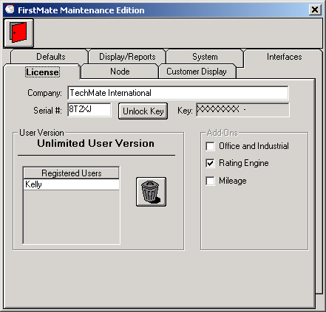
6.3 FirstMate License Tab / Entering a FirstMate Key
The license tab will display the unique Serial number for this installation of FirstMate. When you contact TechMate International to obtain a key, you will need this serial number and you will be given a key. To enter the key, click on the Unlock Key button and remove the current key and ALL SPACES. Then enter the key exactly as it was given to you and hit enter. Once the new key is entered, the user version should change to reflect any add-ons that have been licensed. The Registered Users will have an entry for each FirstMate Node Name. To delete nodes from FirstMate, click on the node you wish to delete and then the delete button. Note: You cannot delete the current node.

6.4 FirstMate Node Tab
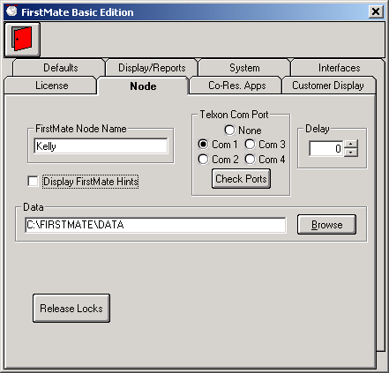
FirstMate Node Name: FirstMate keeps track of nodes that are on FirstMate by the Node Name. This is relatively important in FirstMate multi-user environments because anytime you go into a customer to view or modify the data, that customer will be flagged as locked so two users cannot modify a customer at the same time and over write each others changes.
Telxon Comm. Port: This is the comm. port FirstMate is setup to use. This is discussed further in Changing the Comm. Port in FirstMate.
Delay: We’ve had customer experience trouble connecting SalesMate/Telxon with FirstMate. If you are having trouble establishing a connection with SalesMate/Telxon and FirstMate, contact TechMate International. The tech might ask you to change this delay. It is strongly recommended you do not change this on your own.
FirstMate Hints: Some screens include additional “bubble” hints for buttons and other places on the screen. These are intended to help novice FirstMate users get acclimated with FirstMate but can become an annoyance to experienced FirstMate users. Feel free to turn on and off the hints as you see fit.
Data: This displays where the data resides. For FirstMate multi-user systems, you might need to browse the network to connect to the network FirstMate data. Once again, this feature is for experienced FirstMate users or to be used at the directions of a TechMate International tech’s request.

6.5 Customer Display Tab
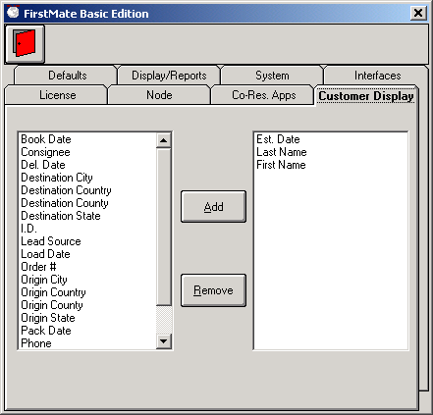
The customer display controls what columns get displayed on the main FirstMate screen. The list on the left displays items that you can display and the list on the right shows items that have been selected. FirstMate will display the items from left to right in the same order as they are shown top to bottom in the display list.
Important note: The main FirstMate screen will sort the customers in the order of first entry in the display list. If the first item is a Date, the most recent will always be on top. It the first item is a name the display will be alphabetic.
Items can only be added to the end of the display list. To delete an item, click on the item and then click on Remove. To add an Item, select the item in the left window and the click on Add and the item will be added to the list.
The items I.D. and Sync are the Salespersons number and the status of communications between FirstMate and Pocket SalesMate or an application using an XML interface.

6.6 Interfaces Tab
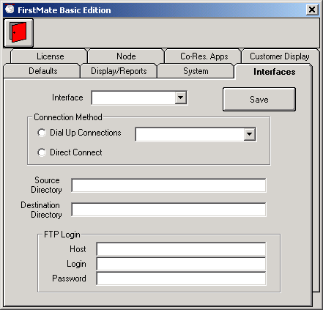
FirstMate has the ability to directly connect to Van Line registration systems. Currently only United and Mayflower agents have this ability but we should be adding more in the future. Setup of the UniGroup Interface is done automatically by downloads from our web page.
To setup the Interface for United and Mayflower, contact TechMate International for details on downloading the appropriate files. If you have a UniGroup icon on your system, the interface has already been setup.

6.7 Co-Resident Applications
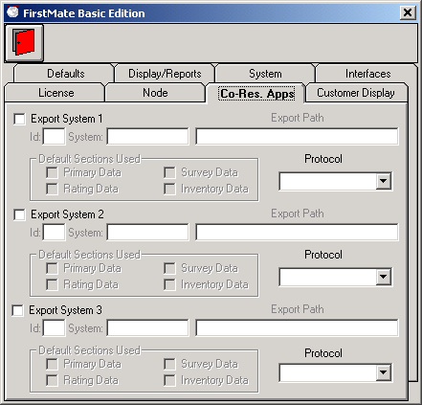
The “Co-Resident Apps” tab is used to setup interfaces between FirstMate and other Applications. TechMate has developed two interface methods for communication (a delimited CSV type file or an XML file).
TechMate is working with a number of software vendors in order to provide integration of our systems to make your job easier. Contact TechMate International for details on the interface or for a full list of applications that can interface with FirstMate and TechMate International full line of products.

7.0 Collecting Customers Information in FirstMate
Now that FirstMate is setup and you’ve had a chance to see the ways it can be configured to better assist you, it’s time to put it to use. When you create a shipper, you will see four tabs for entering data. The Primary Data screen is used for entering the customer’s primary data, the Survey Screen is used for building up the customer survey, the Rating Data screen is used for rating the move and the Inventory screen is used for building up the customer inventory.

7.1 Primary Data Screen
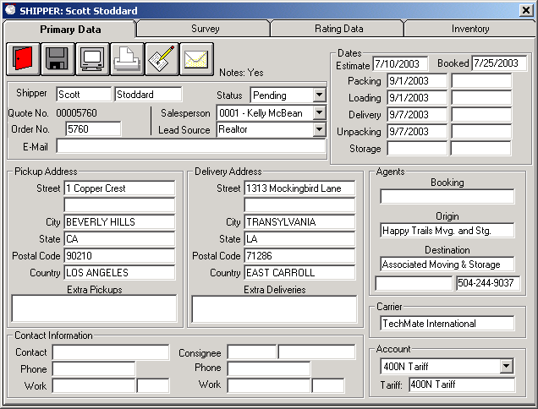
The Primary Data screen is just that, the place to enter the Primary Data. All the shipper and consignee information as well as any extra pickups and deliveries, all the important dates and agents are entered on this screen. If you are a licensed user of FirstMate Rating, you will be able to select the account/tariff from this screen as well.
Let’s add a customer. Click on the “Add New button” on the main FirstMate screen. If you checked the Default Salesperson when you created your user, the Salesperson will already be set. Same with the Origin Agent and Carrier, if you checked Default Origin Agent and set the Affiliation, those will be set as well. Go ahead and enter the Shipper information. If the Zip code and County Lookup that were discussed in section FirstMate Defaults Tab was checked, FirstMate will automatically enter the City, State and County when you enter a Postal Code. Go ahead and enter some dates as well. To enter an agent, just click on the area where the agent is displayed and the list of agents that has been previously entered into FirstMate.

7.1.1 Adding Notes
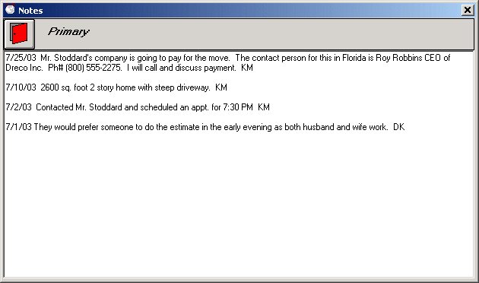
Primary data notes can be added to each customer and the Notes Flag will change to a “Yes” on the primary screen for any customer that has notes. The notes section is for free form notes so any pertinent information about the customer gets saved. All notes will get printed along with the Primary Data Report.
Click on the Notes button on the Primary data screen of our test customer. Enter a sample note and then click on the Exit button. Notice the Notes flag has changed to “Yes”.
In Addition, Notes can be added (and printed with) the Survey and Estimate/Order For Service Reports. Simply click on the Notes icon in the appropriate folder and enter or edit the notes.

7.1.2 Displaying or Printing the Primary Data Report
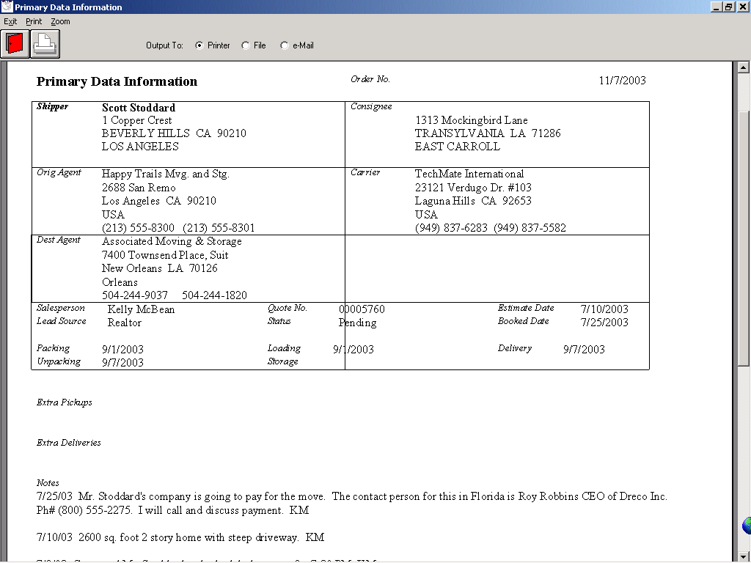
The Primary Data report includes all pertinent information such as the Shipper and Consignee as well as the Carrier, Origin and Destination agents. It will also include dates like Estimate, Booked, Packing, Loading, Unpacking and Storage. As previously mentioned, it will also include the notes at the bottom of the page.
The Primary Data report can be printed directly from the printer or previewed on screen. While previewing, you have the ability to send the report to the printer, save it to disk as a PDF file or send the report as a PDF file attachment via email.

7.2 Survey Screen
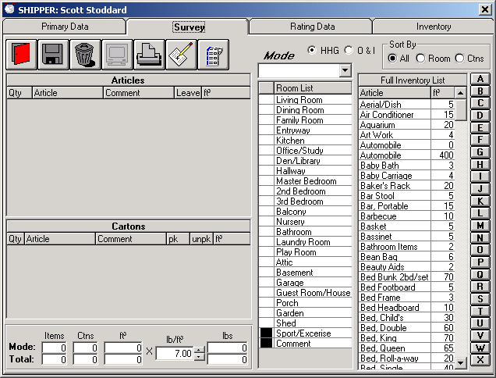
Like SalesMate, FirstMate is a multi-modal surveying tool. Surveys can be created using English or Metric units of measure (see Default FirstMate Tab) and displayed in a number of languages including English, French, German, Spanish, Italian, Portuguese or Spanish with more language on the way. (See FirstMate Display/Reports Tab)

7.2.1 The Inventory List
Displayed in the upper right hand corner of the Survey tab are three Sort options. These sort options control what is displayed in the Inventory list directly below. Setting the sort to “All” will display the Full Inventory list. Setting the sort to “Rooms” will display the Group list that is associated with the current room being surveyed. Setting the sort to Cartons “Ctns” will display the Carrier Pack and Packed By Owner lists. Additionally, clicking on a room description in the Room List will display the associated group for that room.
Alphabet buttons are provided the extreme right that will move the list to Articles starting with the letter of the button that was pressed. 7.2.2 Setting the Mode and the current Room
Since FirstMate is a multi-modal surveying tool, you will need to set the Mode and the Room before you can start to survey. Above the Room List is a drop down list of Modes. FirstMate uses the standard list of modes similar to TechMate Internationals other products that include Road, Local, Sea, Air and Storage. To select a mode, simply click on the drop down list and select a mode. Additionally, you will need to select a Room before you can survey. The Room List is divided into two columns. The left hand column is to select and change the current room being survey. Rooms with no items in them will display a blank in the column, while rooms with items will display a “√”.
A █ in the column represents groups that cannot be selected as rooms to survey to. The right hand column will display a list of all rooms and groups that are not associated to rooms. Clicking on a room or group will change the inventory list to display items that are commonly seen in those rooms or groups.

7.2.3 Adding Articles to the Survey
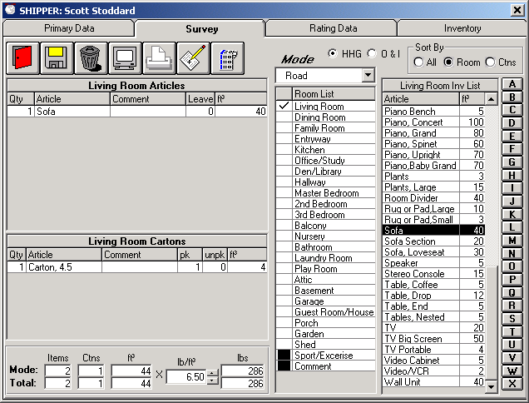
To add an article to the survey, simply click on the article in the Inventory list. Carrier Packed Cartons will appear in the Carton list (below), while all other Articles will appear in the top list. If the Article has already been entered, the quantity for that Article will be increased by 1 for each click. If the Article has a Comment associated with it, a new Article will be entered.
Click on the Mode drop down list and select Road. Click in the column to the left of Living Room in the Room List. Click on the ‘S’ button in the column of buttons to the left of the Inventory list. The Inventory list will change to display articles starting with ‘S’. Click Sofa and you should now have one Article (Sofa) in the Living Room Articles list. Click on the Ctns button and the Inventory list will now be replaced with the Carrier Packed and Packed By Owner Articles. Click on the ‘Carton 4.5’ in the Carrier Packed lists. You should now have a Carton, 4.5 in the Living Room Cartons list. The totals below the Living Room Cartons list should reflect both entries to the survey.

7.2.4 Changing the Quantity and Size of an article
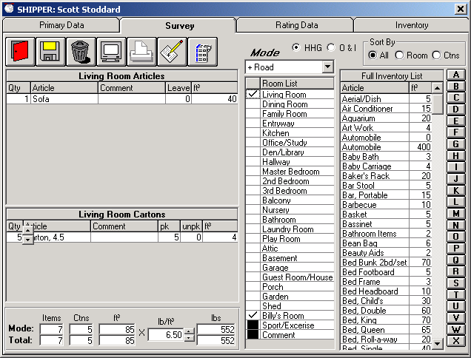
The up/down scroll bar for increasing or decreasing will appear next to the entry whenever the mouse pointer moves over the Qty, Leave and/or Cubes columns for article in the Room Articles list will, as well as the Qty, pk, unpk and cubes in the Room Carton list. To increment or decrement by 1, simply click on the up or down arrow. To change the quantity or size by many, hold down the click on the up or down arrow will scroll the quantities or sizes changes.
Move the mouse pointer over the Qty column for the ‘Carton 4.5’. You will see an up/down scroll bar appear. Click on the up arrow 4 times to change the quantity to 5.

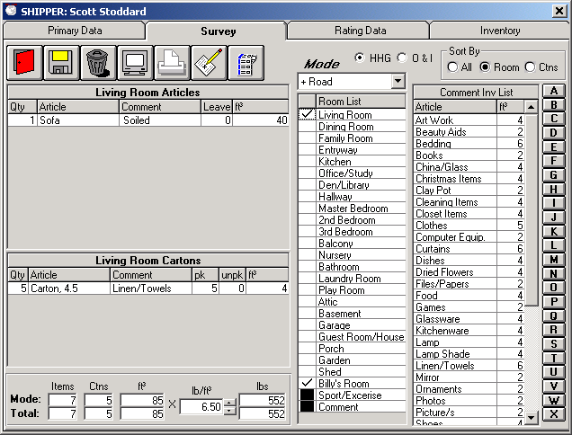
7.2.5 Adding Comments/Contents to an Article or Carton
You can either enter a Comment/Content from the Comment or any other Inventory list or you can manually type in a comment. To add a comment, click in the comment column for the article/carton that you want to enter a comment for. The Inventory list will automatically change to the Comment Inv. List. You can click on a comment from the list, change the list to any other list or just type in a comment, up to 16 characters.
Click in the comment column for the Sofa in the Living Room Article list. Type in the comment ‘Soiled’ and press enter. Click in the comment column for Living Room Cartons. Click on ‘Lined/Towels’ in Comment Inv List and the comment will be added.

7.2.6 Adding Miscellaneous Rooms and Articles
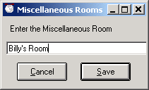
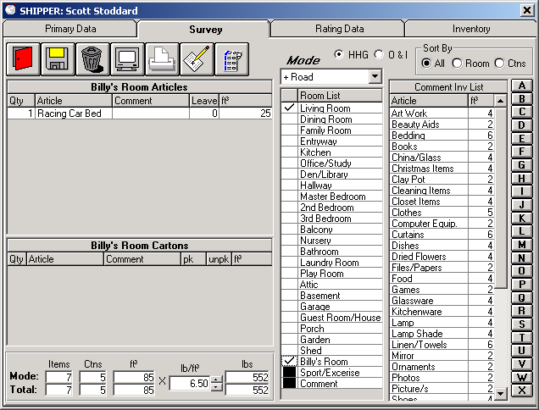
To add a miscellaneous room, click on the word Room List in the Heading Column of the Room List. This will bring up a screen to enter the room name. Click on Save and the Miscellaneous will be added to the Room List below the rooms and above the groups. The room will also be set as the current room to survey to.
Click on the word Room List to enter a Miscellaneous Room. In the Miscellaneous Room entry screen, enter ‘Billy’s Room’ and click on the Save button. You should now see the new room added to the room list and the current room to survey to will be Billy’s Room Articles.
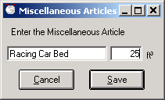
To add a miscellaneous article, click on the word Article in the Article column of the Room Articles list. This will bring up a screen to enter an article description and size. Click on save and the miscellaneous will be added to the current room being surveyed.
Click on the word Articles in the Articles column of the Room Articles list to enter a Miscellaneous Article. In the Miscellaneous Article entry screen, enter ‘Racing Car Bed’ and enter 25 as the cubes then click on the Save button. You should now see the new article added to the Room Article list with the cubes.

Entering Crates
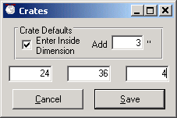
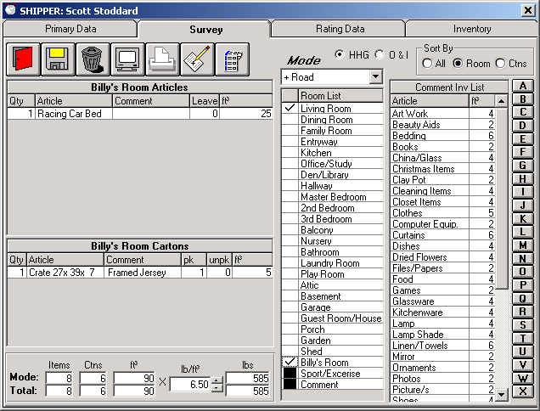
To add a crate to the survey, click on the Ctns button to change the Inventory display to list the Packed By Owner and Carrier Packed Carton lists. Find and click on the Crate in the Carrier packed list. The crate entry screen will come up where you can enter the crate dimensions. You need to the dimensions and then click Save. You can either enter in dimensions of the Crate or the dimensions of the Article (note the selection in Crates Details). The default is set in the FirstMate Defaults Tab.

7.2.8 Displaying or Printing the Primary Data Report
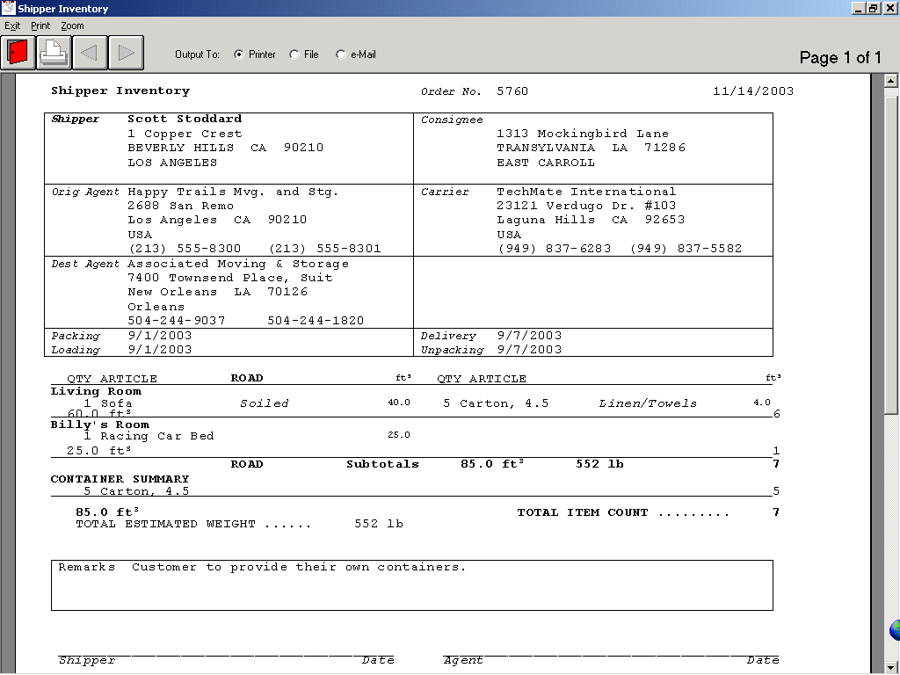
The Shipper Inventory report includes all pertinent customer information such as the Shipper and Consignee as well as the Carrier, Origin and Destination agents. It will also include the Packing, Loading, Delivery and Unpacking dated.
The Shipper Inventory report can be printed without any reference to cubes, with only the cube totals or the cube totals and details. The Shipper Inventory report can also be printed in any of the languages currently supported by TechMate International’s products. For a complete list see FirstMate Display/Reports Tab.
The report will give a detail listing of all the surveyed articles and cartons, including comments. The report is broken down to list all articles separated by mode and then room and will include a container summery section for each mode. The report includes totals section, the remarks and lines for both customer and agent signatures at the end of the report
The Shipper Inventory report can be printed directly from the printer or previewed on screen. While previewing, you have the ability to send the report to the printer, save it to disk as a PDF file or send the report as a PDF file attachment via email.

7.2.9 Printing Bar-Coded Labels
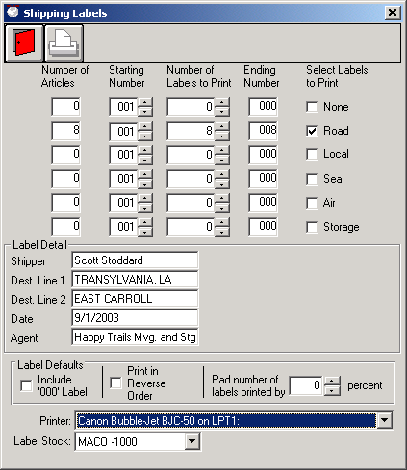
LoadMate users that wish to print bar coded Labels can do so directly from FirstMate. Clicking on the Shipping Label button will bring up the Shipping Label screen. The Shipping Label screen will display the destination address and Origin Agent as entered in the Primary Data screen but can be changed if needed. FirstMate will display the number of labels to print broken down by mode, which is calculated from the total number of items surveyed plus a % pad. The user can set the starting number; modify the actual number to print. Default label percentage pad and mode color bars can be set in the FirstMate Display/Reports Tab.

Rating
This section covers Rating within FirstMate.

7.3.1 Tariff Selection
The selection of the Tariff is made on the Primary Screen in the Rating’s area at the bottom right portion of the screen. Only initialized Tariffs are available for selection. If a desired Tariff is not listed in the drop down list, go to Setup - Tariff Files and initialize the desired Tariffs.
The Tariff can be changed at any time by simply selecting another Tariff from the drop down list.

7.3.2 Tariff’s Bind Date
In FirstMate, when you pick a Tariff (e.g. 400N), the Bind Date is used to indicate that the rates effective on that date are used in Rating. Currently the Bind Date cannot be set on the Primary Data tab. The Bind Data will default to today’s date, but can be changed in the Rating Data tab.
When a Tariff is selected, the Bind Date will be set to today’s date. It can then be locked into a specific date in the Rating Data Tab. The first time a tariff is rated, the Survey will be processed before rating. After that, you must specifically indicate “Rate Survey” to process the survey. FirstMate Rating allows you to completely control Packing charges and Light & Bulky charges, so it is not necessary to go back to the Survey for these items.

7.3.3 Rating Data Tab
Following is an example of the Rating Data Window.
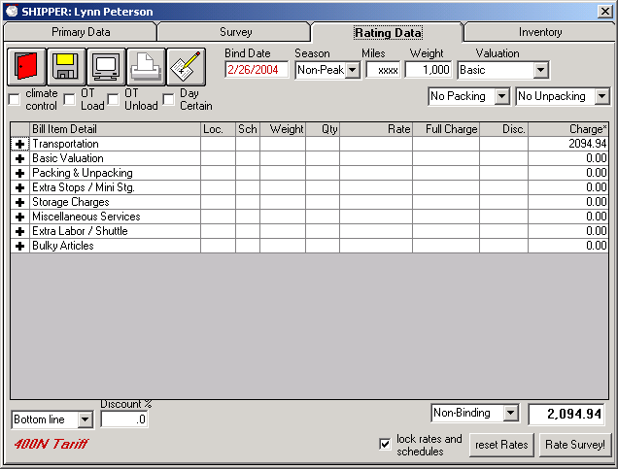

All Tariffs have a similar look and feel. The Bind Date, Season (Peak or Non-Peak), Miles, Weight and Valuation choices (Basic, Depreciated or Replacement) are shown at the top of the screen. If the tariff you are using gets miles from the Rand McNally Mileage Guide, the Miles field will be displayed as “xxxx” since Rand McNally contractually limits us from showing the miles.
You can display the Estimate/Order for Service on screen and then print or e-mail. If you want to enter notes that will print on the Estimate, click on the pencil icon.
For some Tariffs, certain options (e.g. Overtime Loading, Climate Control, etc.) are shown as check boxes.
Items within the Tariff are combined into groups (e.g. Transportation, Packing & Unpacking, Storage, etc). The groupings are similar to the way they are organized on the Estimate/Order for Service report. The subtotal for each Group is initially displayed (there will be a “+” shown in the left most column. If you click on group’s “+”, all items in that group will be displayed and the group header will now have a “-“ in the left most column. You can return a group to its subtotal display by clicking on the “-“ on the group header.
When a Group is expanded to show all items, you can click on an Item to open a window that will allow you to make changes. Once desired changes have been made, clicking on the Red Door Icon will return you the display of the Tariff items.
Handling of Packing charges are handled specially within FirstMate. You can expand the Packing & Unpacking Group to show the charges, but you need to click on any other part of the Packing & Unpacking Group header to make changes. Go to the Section for Container, Packing and Unpacking Charges for details.
The Discount choices, Contract Type and the total estimated cost are shown at the bottom of the window. . If you are using the TPG Tariff or using a Bottom Line Discount, the total can be changed and either the SMF or discount will be adjusted accordingly.
If you want to change the Weight for example, simply key in a new weight and press the tab key.
If you want to change the Bind Date, simply key in the desired data and press the tab key.
Discount options and discounts are selected at the bottom left portion of the window.

7.3.4 Transportation Charges
All Inter State Tariffs have Rates that are based on the Miles and the Weight of the shipment. If you are using a Tariff that uses Rand McNally miles, the miles will be determined from Zip codes. If the miles field is not displayed as “xxxx”, you will have to enter or adjust the miles.
The Weight will initially be determined from the Survey. The Weight can be adjusted at any time to whatever you desire (of course, subject to Tariff minimums). If you go back and change the Survey, FirstMate WILL NOT automatically re-rate the Survey. If you wish to re-rate the Survey, you must click on the Re-Rate Survey command button in the Rating Tab. If you do re-rate the Survey, Weights, Container Counts and Light and Bulky charges will be reset.

Local Transportation & Labor Charges
The Local, Intra State, and International Tariffs all have charges involving the selection of the number of Vans and Men. For these to work it is necessary to enter both a 1 Van and 2 Man Rate and then an Extra Man Rate in Setup.
When you click on a Van & Men item, you then can enter the number of Hours, the number of Vans and the number of Men and the resulting rate and total will be calculated. In all cases, you can change the resulting Rate.

Valuation Charges
Valuation choices are made by by clicking on the Valuation drop down list. If Depreciated or Replacement Valuation is selected, the minimum valuation will be calculated and displayed and a text box will be provided to allow you to enter another Valuation amount.
The resulting Valuation Charge will be displayed on the Valuation Subtotal line. No changes can be made on in this area for Valuation.

Cartons, Packing & Unpacking Charges
For all Tariffs, you have the option of using Container and Packing rates separately or to combine them into a Single Pack rate. The default for the 400N Tariff is a Single Pack rate. If you are using a Single Pack Rate, the Packing Window will have two combo boxes (Packing and Unpacking) to allow you to rapidly change your choices. If you use separate rates for Containers and Packing, there will be a third combo box for Container charges.
Again after rating the Survey, the column on the left will be the number of Carrier Packed Containers entered in the Survey. You can decouple from the Survey and adjust the quantities in the left hand Qty column. In this case, you can change quantities by using the left most column. FirstMate will not rate the Survey unless you specifically select “Rate Survey”. You can control your Container, Packing and Unpacking quantities manually by leaving the selections in the “Manual” mode. In this case, the left column will not be used and you need to set all quintiles manually. If you use the other selections (e.g. Unpack, Breakables & Mattresses), the quantities will be set automatically from the left column. By using the automatic settings, you can quickly get the estimated costs for the “what if” questions on Packing costs.
The following example shows the selections of Packing, All (this is Unit Packing) and Unpacking, Brekable/Matresses. Then Quantities for Packing and Unpacking have been automatically set from the Qty column to the left of the Containers name.

.

Extra Stops / Mini Storage Charges
.

Appliance Servicing Charges
.

Elevator, Stairs & Long Carries Charges
.

Piano/Organ Charges
.

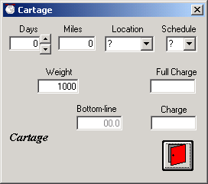
Storage (S.I.T) Charges
In order to make choices for SIT simpler, all choices relative to SIT can be shown in a single Window. Simply select where Storage is (Origin or Destination), set the number of days of Storage, enter Cartage Miles and make a change to the Weight if desired and exit. All SIT charges will then be calculated. If you want to turn SIT off, simply click on the left column of the SIT Item and an “x” will be displayed, indicating that SIT is turned off. Clicking on any “x” will turn SIT back on. To change items within SIT, click on the “Cartage” line

Other Storage Charges
..

Miscellaneous Charges
.

Extra Labor / Shuttle Charges
.

Bulky Article Charges

Taxes Charge
The generic International Tariff allows the ability to set a Tax on all charges.

Discounting

Estimate Type

Total Charges (changing)

9.0 Interfaces with TechMate’s Portable Products
One of FirstMate’s primary features is that of a central hub for customer data that is collected via one of the TechMate International’s line of portable products. You’ve seen how to create a customer and enter the primary information into FirstMate. Now this section will show you how to get that information into one the portable products and back again.

9.1 SalesMate/Telxon
To download a customer to SalesMate/Telxon, connect the SalesMate/Telxon (See: 5.1.1 Connecting SalesMate/Telxon to FirstMate). The SalesMate/Telxon screen will show “FirstMate on line…” and the FirstMate screen will split to show the customers in the SalesMate/Telxon on the left and the customers in FirstMate on the right while the SalesMate/Telxon is on-line. Customers that are assigned to other sales persons will not be displayed when the SalesMate/Telxon goes on-line. (If a desired customer is not being displayed when the SalesMate/Telxon goes on-line, unplug the Telxon and verify the Salesperson in the Primary Data is set to the appropriate sales person. If it is, verify the Salesman ID in the SalesMate/Telxon matches that of the ID in the Users section for this sales person in FirstMate.) Right click to hi-light the customer in the FirstMate Customer list (right side of FirstMate screen). The Download to SalesMate/Telxon button should become active. Click on the button and you will see the download status appear at the bottom of the FirstMate screen. When the customer download is complete, you will see the customers name in the SalesMate/Telxon list on the left side of the screen.
Connect the SalesMate/Telxon to the PC to Telxon cable. Make sure FirstMate is at the main screen and the SalesMate/Telxon is on. Press the B button on the SalesMate/Telxon. Right click on a customer in the FirstMate list and click on the Download to Telxon button. Once the download has completed un-plug the Telxon. Go into the customer in the SalesMate/Telxon and make changes (i.e. edit dates, shipper, consignee, survey, rate, etc.). Exit back to the SalesMate Menu screen on the Telxon, plug the /Telxon back into the PC to Telxon cable and press the B button to get the SalesMate/Telxon back on-line. Right click on a customer in the SalesMate/Telxon list (left side of the FirstMate screen) and click on the Upload to FirstMate button. Once the upload is complete, un-plug the Telxon and go into the customer in FirstMate and verify the changes you’ve made.

9.2 Pocket SalesMate
A connection must be setup with a Pocket SalesMate (5.2 Setting up a Connection with Pocket SalesMate.) in order to upload or download a customer using Pocket SalesMate. It is recommended that the Sync be added to the customer displayed as list in FirstMate. (See 6.5 Customer Display Tab.)

9.2.1 Sending a Customer to Pocket SalesMate
To download a customer to Pocket SalesMate, right click to hi-light the customer in the FirstMate Customer list and click on the “pocket PC” button. The customer files will now be built and ready to export to the Pocket SalesMate the next time the Pocket SalesMate is synched. If the Sync column has been added, a “??” will be displayed in the Sync column. Once Pocket SalesMate processes the file, it will return to FirstMate a confirmation that it has processed the customer file. If the Sync column has been added, an “ok” will be displayed in the Sync column once the confirmation is received.
Right click on a customer in the FirstMate list and click on the pocket PC button. Synch the Pocket SalesMate. Pocket SalesMate can take up to 30 seconds to import the file. Once the file is imported, it will appear in the customer list in Pocket SalesMate.

9.2.2 Sending a Customer from Pocket SalesMate
To upload a customer from Pocket SalesMate, tap in the sync (2nd column from the right, left of the “X”) column in the customer display list on the main form of Pocket SalesMate. Click yes on the prompt to “Build file for export?” The sync status column in the customer display will turn yellow to show the customer transfer is pending. Sync the Pocket PC and start FirstMate. It could take up to a minute for FirstMate to retrieve and process it the file. Once FirstMate has processed the customer file, a confirmation will be sent back to Pocket SalesMate and the sync status column in the customer display will turn green.
Go into the customer that was just transferred to Pocket SalesMate and make changes (i.e. edit the dates, shipper, consignee, survey and or rate). Return Pocket SalesMate to the Customer display screen and click on the “X” in the sync column for the customer. Click yes on the prompt to “Build file for export?” If the Pocket PC is not synched, sync it now. When the sync status column turns green, go into the customer in FirstMate and verify the changes were made.
Master Inventory Customization

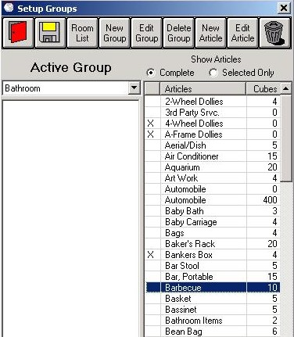
The Master Inventory can now be customized for each agency. To access the Master Inventory screen, select the Master Inventory option from the Setup drop down menu from the Main FirstMate screen.

Creating and Editing Articles
From the Group Setup screen, articles can be created (by clicking on the New Article button) or edited (by clicking on the article and then the Edit Article button).

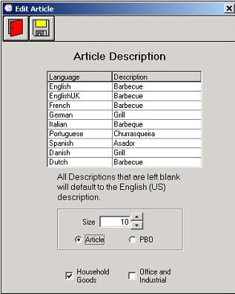
Once the Edit Article screen comes up, enter the English description and any translated languages needed. Any language translation left blank will default to the English translation.

Next, enter the size and if it’s a normal article or PBO carton. PBO cartons will appear in the carton list at the end of the Shipper Inventory Reports when doing surveys. Finally, select if this article is a Household Goods, Office and Industrial item or both.

Groups

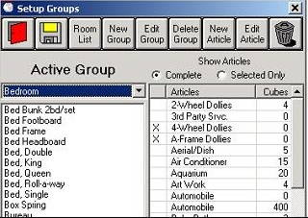
“Groups” are used to group items into common categories. To create a new group, click on the New Group button. From the Group Description screen, the Group name is entered and if this group is an O&I group. The group can also be pre-populated with the articles from another group to use as a starting point.

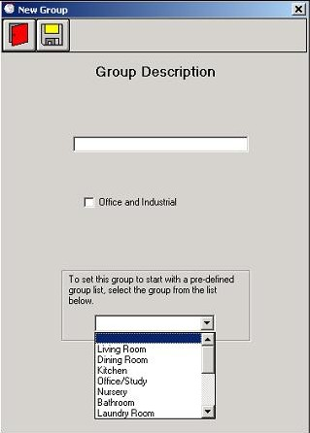
To add items to the group, from the Setup Groups screen, double click on the article on the left. To remove articles from the group, double click on the article to remove from the left.

Creating Rooms and Assigning Groups

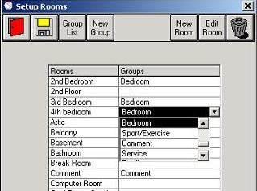
To create a new room, from the Setup Room screen, click on New Room button. Similar to the crating an article, enter the English description and any translated languages that are needed. Any language translations left blank will default to the English translation.

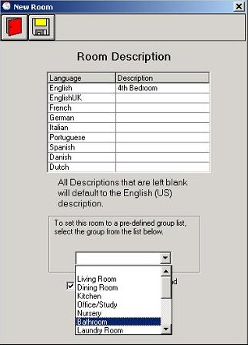

Assigning a group to be used by the room can be done in two places. When the room is created or is being edited, there is a drop down list with all the groups or in the Setup Rooms screen there is an overview of all the rooms and the groups assigned to them.

Sending the Customized Master Inventory to Pocket SalesMate

The Customized Master Inventory can be sent to and used in Pocket SalesMate. From the main FirstMate screen, click Setup and then Pocket PC. Select the user(s) and from the Inventory tab, check the HHGI box. Send the file using the same process as when sending any other file.

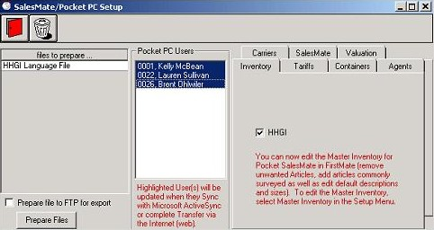

Scheduler

Salespeople must be included in the scheduler before they will appear in the schedule screen. To setup a salesperson to be used in the scheduler, go into the user’s screen for the salesperson (from the main FirstMate screen, click Setup and Users then on the salesperson to setup.) Click on the Scheduler tab and then add a check in the “Include in Scheduling” area.
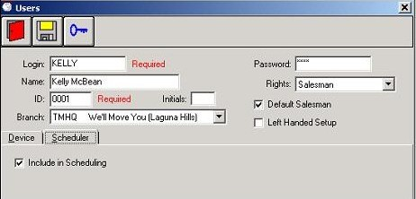

To bring up the schedule screen, click on the schedule button from the main FirstMate screen.

Feature Notes
- Branch: If agencies have multiple branches, each branch can be set as a Branch office and then each user can be designated to a branch. This is discussed later in the Branch and Access section.
- Initials: This field can be used for tracking the initial appointment taker. This is described in the Creating an Appointment section.
- Left-handed orientation for the survey screen has been implemented. This is discussed in the Left Handed Survey Screen section.

Displaying Appointments

Appointments can be displayed in 2 views. The office view will display all appointments for all the salespeople for a given day. To change the day, click on either arrow or type in a new date. (Note: Users logging in with Salesman rights will not see this screen. They will go directly to the individual salesperson’s screen described below.)
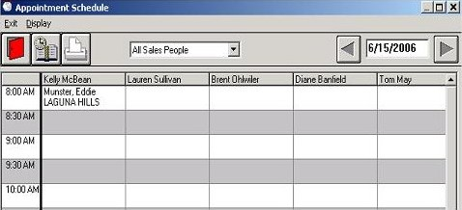

To view appointments for an individual salesperson, click on the Salesperson dropdown list and select the salesperson. This will show all the appointments for the salesperson over a 7-day spread. Reports can be printed from both screens in similar format displaying the same information that is shown on the screen.

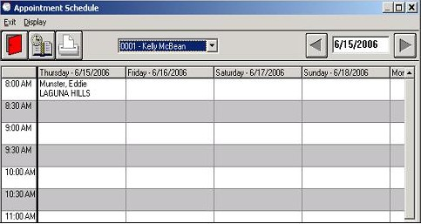

Creating an appointment

By clicking on the desired appointment time for either the salesperson or date (depending on the appointment screen view), a screen will come up with some information already pre-populated. (Estimate Date, Time, Booking and Origin Agent if they have been set as defaults and the Salesperson.) The rest of the customer information can then be entered here.

Appointments taken will appear in the Prospects list on the main FirstMate screen
Note: The “Apt.Taken by” is a list of the users that have Initials entered as previously discussed.
(An Apt. Taken By report will be implemented in a future version.)

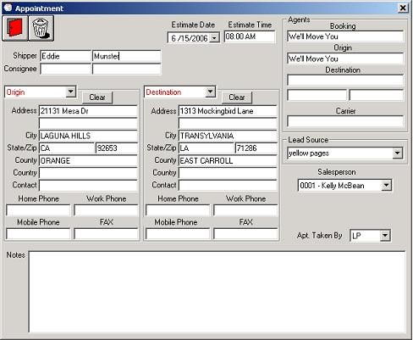

Additional Residence Information Screen
There is a new button on the shipper screen. This button will give access to the new “Additional Residence Information Screen”. The information collected here can be gathered when the call is initially made to the agency or by the sales person using FirstMate on a tablet PC at residence. (This information will be added to Pocket SalesMate in the future.)

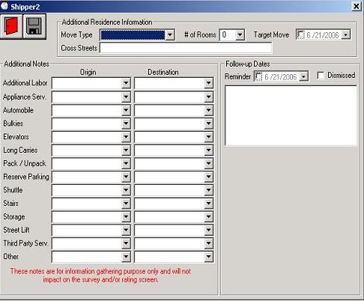
- Move Type: This is pretty much an Agency defined use and works similar to the Lead Source. From the main FirstMate screen, there is now a new option in the drop down menu that brings up the Move Type setup screen. From there, they can define Move Types (up to 25 characters). This can be used for whatever the agency wants.
- Target Move Date: This is meant to be the date the shipper would ideally like to move.
- Additional Notes Fields: These fields allow the salesperson to make comments (up to 25 characters) on various move issues. Comments can be pre-entered from the Residence Notes screen (accessed from the new Residence Notes option on the drop down menu in the main FirstMate screen) and then select from the drop down list or typed in directly into the comment fields.

Reminders

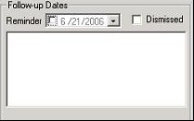
It is now possible to enter task reminders for each customer.

To setup a reminder, enter a date for the reminder and any notes in the box. When FirstMate is launched, reminders for the current day will be displayed with the notes and phone numbers. To manually turn off a reminder, click in the Dismiss check box. Reminders will only be displayed from the main FirstMate screen.

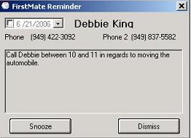
When the reminder is displayed, there are 2 choices, Dismiss and Snooze. Dismissing a reminder will turn off the reminder so it will not appear again. Clicking Snooze for a reminder will place it back in the que to be redisplayed in 60 minutes. Shutting down and restarting FirstMate will reset the que and all reminders for the day will be redisplayed again.

Reminders will only be displayed in FirstMate systems with login enabled or systems with a default salesperson selected. Reminders will only be displayed for the person logged in or the default salesperson.

Customize Generic Verbiage for Local and Intrastate Tariffs

Generic tariff verbiage can now be customized to conform to local and regional guidelines for Local and Intrastate tariffs only. To customize the verbiage, from the main FirstMate screen, click on Setup and then Tariffs. Click on the tariff to make the verbiage changes to. In the upper right hand, you see buttons for the different kinds of contracts allowed for the tariff.
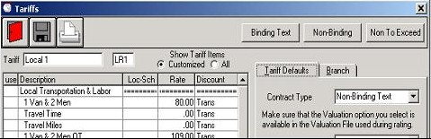

Click on the contract type that will be changed. Each block of verbiage that can be changed will be displayed with the current verbiage.

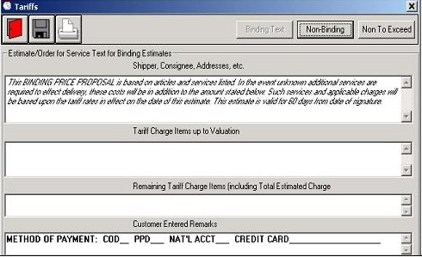
To modify an existing block of verbiage, simply click on the text. The modify text window will popup with the current verbiage and all format setting for the block. Formatting can only be done for the entire block, underlining select words in the block is currently not available. To completely remove the block, clear out all the text.

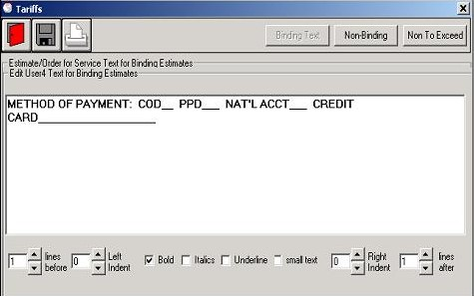

Setting Tariff Defaults

You now have the ability to set tariff defaults. (i.e. discounts). These tariff defaults will be set for new customers created in FirstMate.

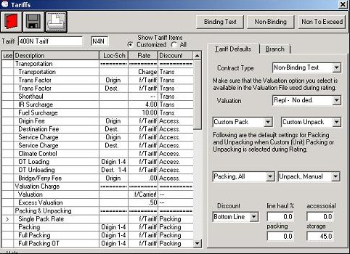

Remote Tablet FirstMate Connecting to the Office Data

Tablet PCs setup as FirstMate companions can now be setup to connect to the FirstMate office data as well as automatically transfer any customer files to/from the office when connected to the office network.
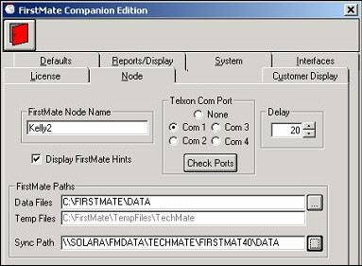
The link must be established in FirstMate for the connection. From the main FirstMate screen, click on Setup and then FirstMate. Click on the Node tab and then the path to the FirstMate data at the office can be browsed to using the
button.

Note: You will need to be connected to the office to be able to browse to the data.

Popup Calendars

Popup calendars have been added throughout the program to replace manual date entries.

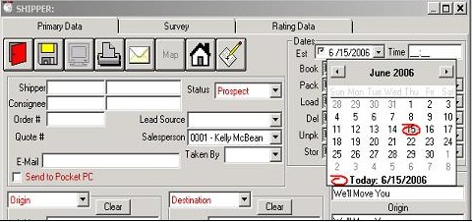

Left-Handed Survey Screen

To accommodate left-handed users running FirstMate on tablet PCs; there is now a left-handed orientation that will now swap the Inventory lists with the Surveyed article grids. By moving the inventory lists, the arm will no longer be blocking the surveyed articles when entering articles.

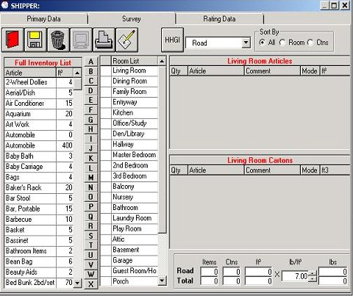

Complete Additional Extra Pickup and Delivery Addresses

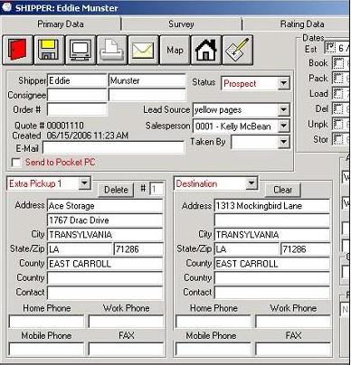
You now have the ability to enter additional pickup and delivery addresses. These addresses will additionally be used in rating and calculating miles. (These additional addresses currently do not print in the headers of the Survey or Estimate reports but will be added in future versions.)

Origin Address Map

Maps of origin address can be displayed and printed using Mapquest.com with Internet connection.


After entering the origin address, click on the Map button. For Pocket SalesMate users, maps can also be easily downloaded to Pocket PCs.
